Distributor: PO #:
Job Name: Door Type: Architectural Craftsman
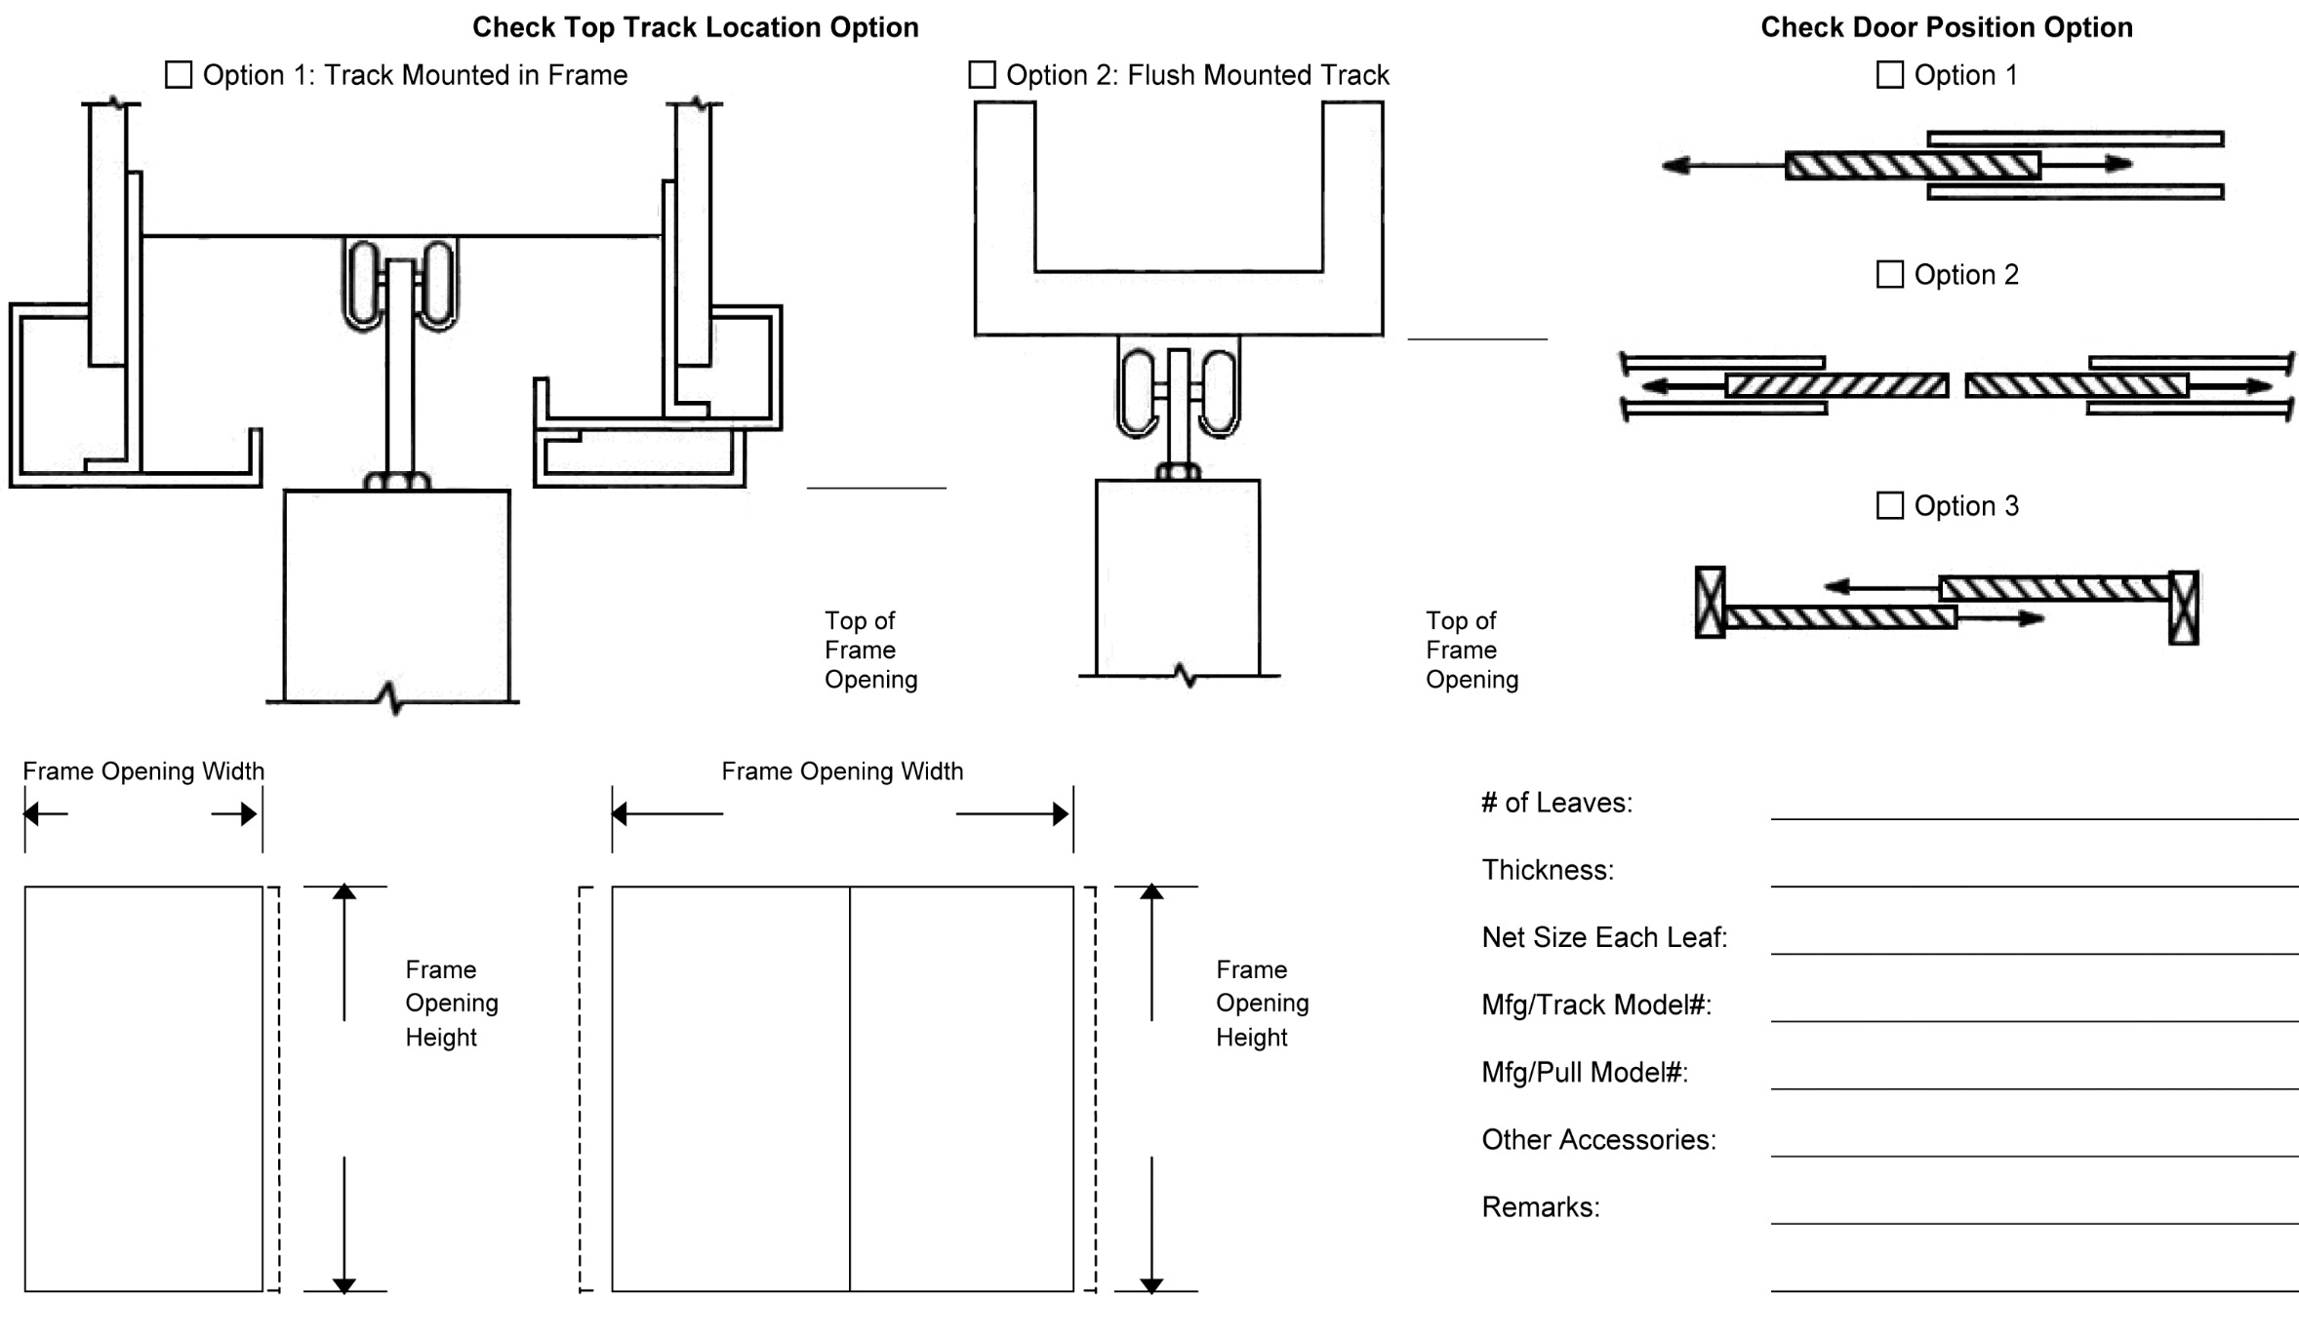
Door #: Face Material:

☐

