Date: (1) Prepared by: (2) Page: (3) of .
(4) ☒Architectural ☐Craftsman Job Name: (5) PO #: (6)
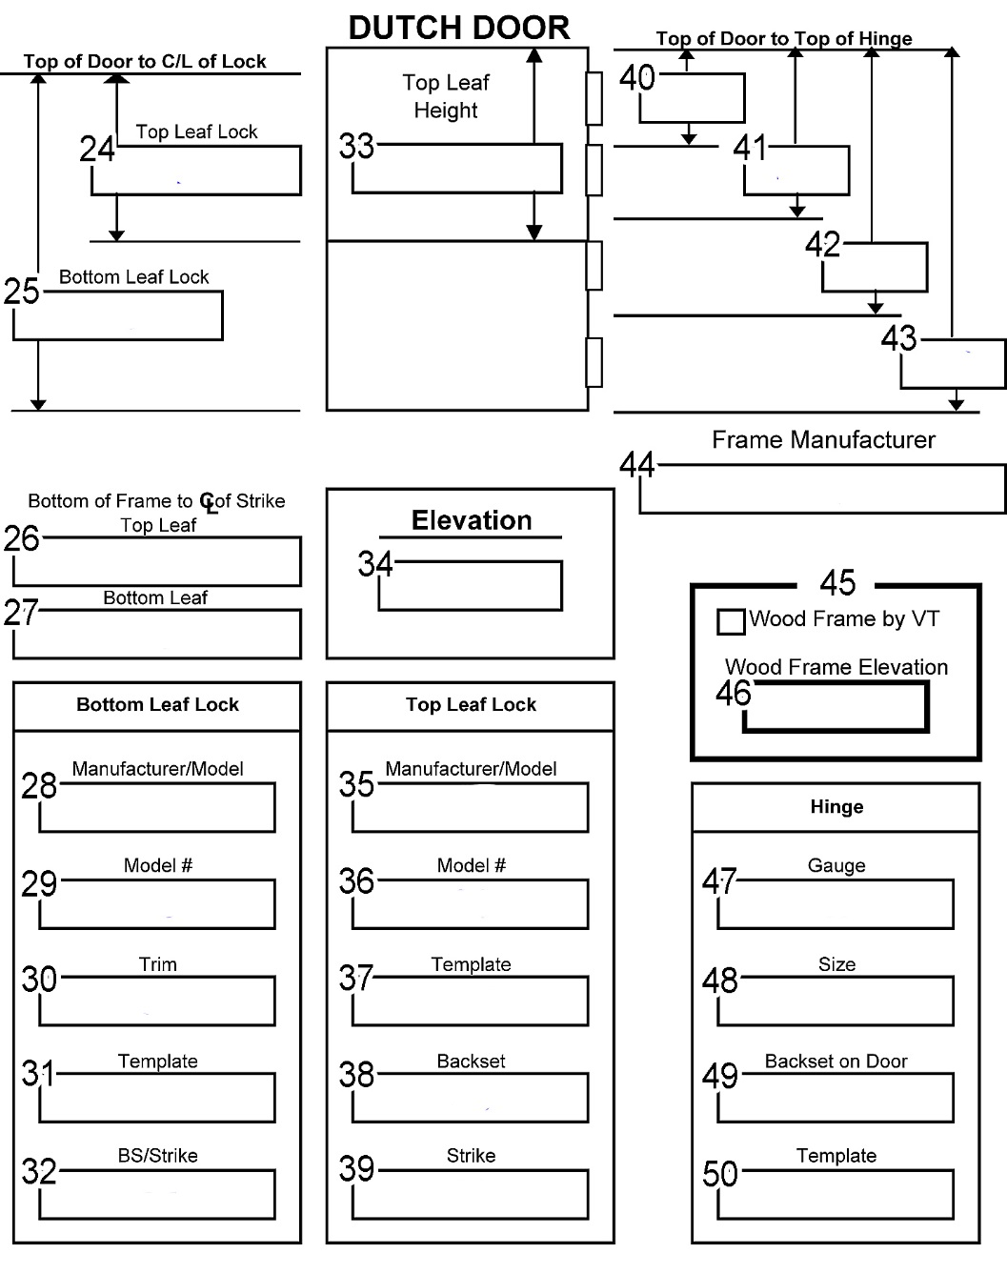
Core: (7) Rating: (8) Face Material: (9)

Stile Finish: (10) ☐Unfinished ☐Finished ☐HPDL ☐Painted ☐Primed
Frame Opening Size: (11)
Prefit Door Size: (12)
Flushbolt(s) Template: (13) ☐Top ☐Bottom ☐Set
Flushbolt(s) Number: (14)
Inner rails: Top: (15) ☐5” or Bottom: ☐5” or Lockblocks (16) ☐Yes Qty:
Other hardware/remarks? (17)
Standard shelf width is frame opening minus 6”, advise if different.

(20) ☐No shelf ☐Shelf stop face ☐Shelf hinge face ☐Shelf centered both faces
Door #’s (21): | Swing: (22)
Quantity of doors on this page: (23)

