Distributor: PO #:
Job Name: Door Type: ☐Architectural ☐Craftsman
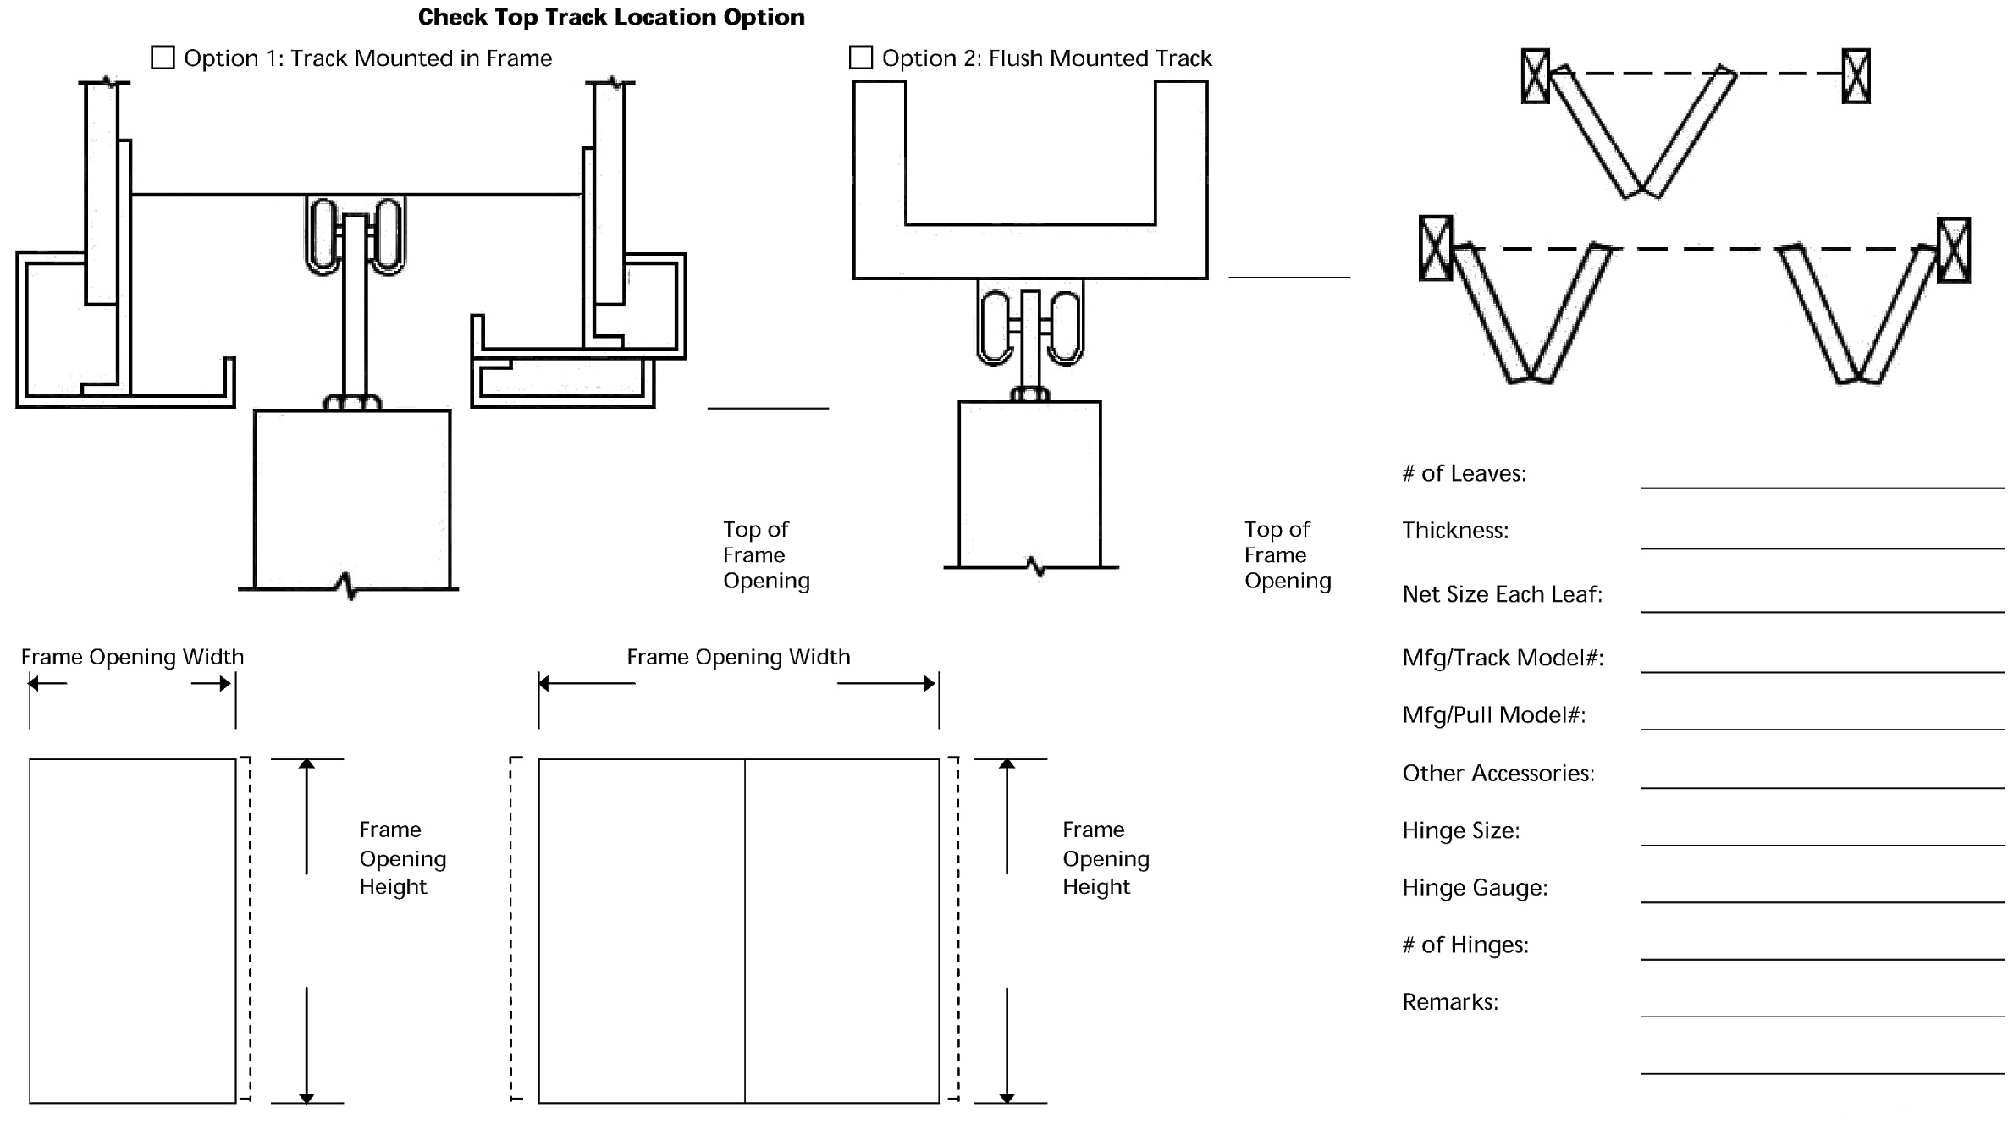
Door #: Face Material:

☐ ☐

